Philadelphia University
Faculty of Information Technology
Department of Software Engineering
Examination Paper

Lecturer : Dr. Samer Hanna and Dr. Adb-rahman Obaidat
Internal Examiner: Dr. Ali Fouad
Coordinator: Dr. Samer Hanna

Object Oriented Data Structures
(0721221 ) Section 1 and 2 First Exam First Semester of 2016-2017
Date: Thursday, Nov. 17th, 2016-------- Time: 50 min.

Information for Candidates
- This examination paper contains 5 questions totaling 20 marks.
- The marks for parts of questions are shown in round brackets.

Advice to Candidates
1. You should attempt all questions.
Basic Notions
Objectives. The aim of the questions in this part is to evaluate that you have the required minimal knowledge and skills. Answers in the pass category represent the minimum acceptable standard.
Q1) (5 marks)
      - (4 marks, 1 mark for each branch)

Choose the proper Data structure (stack, unordered list, ordered list, queue, tree, binary tree, binary search tree, heap, hash table, graph, complete graph, directed graph) that fits each of the following descriptions:

A) Linear data structure where you can delete any item with no restriction and when you insert new element it will be the last element.
B) Linear data structure where first element inserted is the first element deleted.
C) Nonlinear data structure where maximum value is stored In the root.
D) Nonlinear data structure where the value of each node is greater than the value of any node in its left sub tree.
2. (1 mark)

Give an example of a Binary Search Tress (BSF) with 7 nodes.

Familiar Problems Solving
Figure 1. A class Diagram
Objectives. The aim of the questions in this part is to evaluate that you have some basic knowledge of the key aspects of the lecture material and can attempt to solve familiar problems.

Q2) (4 marks)
Write a segment of code in main method that use list data structure to do the following

- Create an empty list “L1” then insert 20 integer numbers by user. (2 marks)
- “L2”is object of list that has integer numbers, write code to print the summation of these numbers. (2 marks)

Q3) (4 marks)
There are three criterions to consider when choosing a proper data structure for a certain requirement; specify and then discuss these criterions with an example. (3 marks for the criterions and 1 mark for the example)

Q4) (4 marks)
Suppose that you have the code of a class called List<T> implemented in Java to represent an unordered list; suppose also that you have the code of a Car class that has two attributes: car brand and year of manufacture. Suppose that you created a list of Cars; write the code of a method that is responsible for deleting a Car object from this list.

Unfamiliar Problems Solving
Objectives. The aim of the questions in this part is to evaluate that you can solve familiar problems with ease and can make progress towards the solution of unfamiliar problems, and can set out reasoning and explanation in a clear and coherent manner

Q5) (3 marks)
Consider the following unordered list class, add new method “Search” where this method take an item as input then search the list, if the item is in the list method will return true else it will return false.
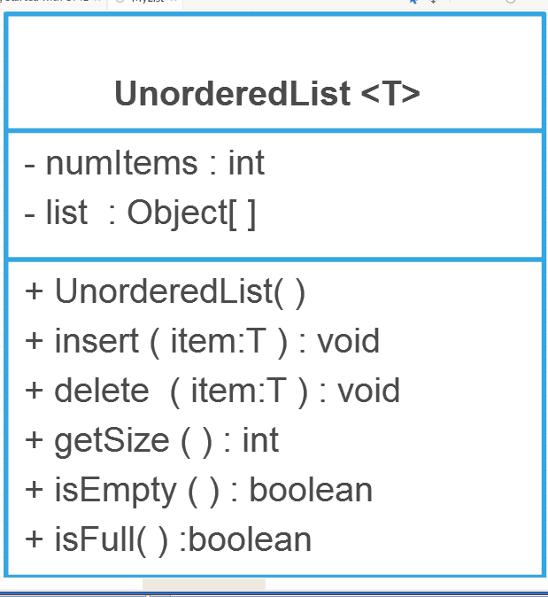

Good Luck

